**Database Practical Week 6**

Part I: MySQL Workbench

Please find below some of the DB scenarios we covered in weeks 4 and 5. Your tasks today are: 1- Compare the answers with your answers in the log-book. 2- For each entity, add a suitable set of attributes (if needed). 3- Use MySQL Workbench to draw each of the diagrams. The link below contains detailed instruction on using MySQL Workbench: [https://drive.google.com/file/d/0B2_t9aZ197ElUGhzM2h3clNlUDg/view?usp=sharing](https://www.google.com/url?q=https://drive.google.com/file/d/0B2_t9aZ197ElUGhzM2h3clNlUDg/view?usp%3Dsharing&sa=D&usg=AFQjCNGijKaNrbNK2R9oOTAOAYbxz3AQWg)

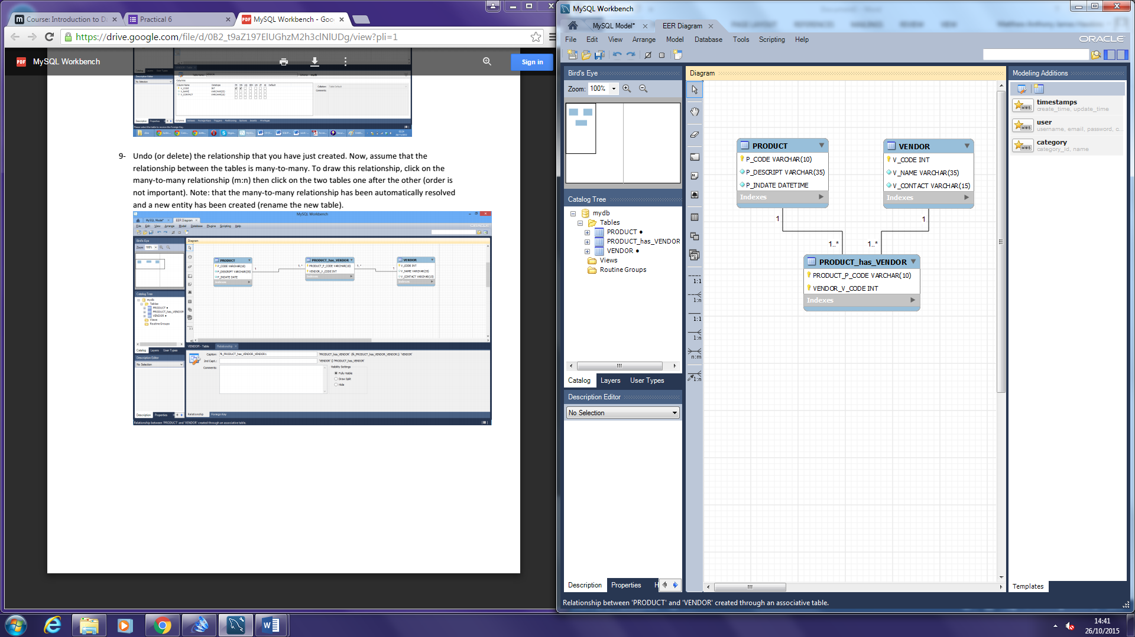

Part II: Scenarios (from weeks 3, 4 and 5)

Scenario 1:

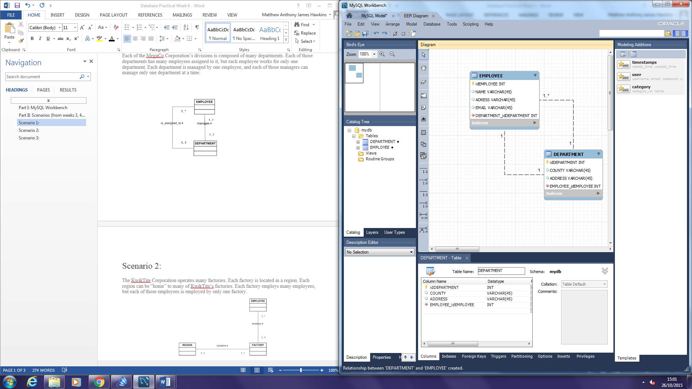Each of the MegaCo Corporation’s divisions is composed of many departments. Each of those departments has many employees assigned to it, but each employee works for only one department. Each department is managed by one employee, and each of those managers can manage only one department at a time.

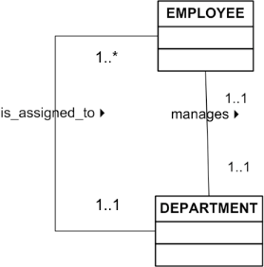

Scenario 2:

The KwikTite Corporation operates many factories. Each factory is located in a region. Each region can be “home” to many of KwikTite’s factories. Each factory employs many employees, but each of those employees is employed by only one factory.

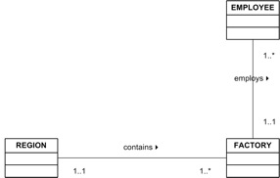

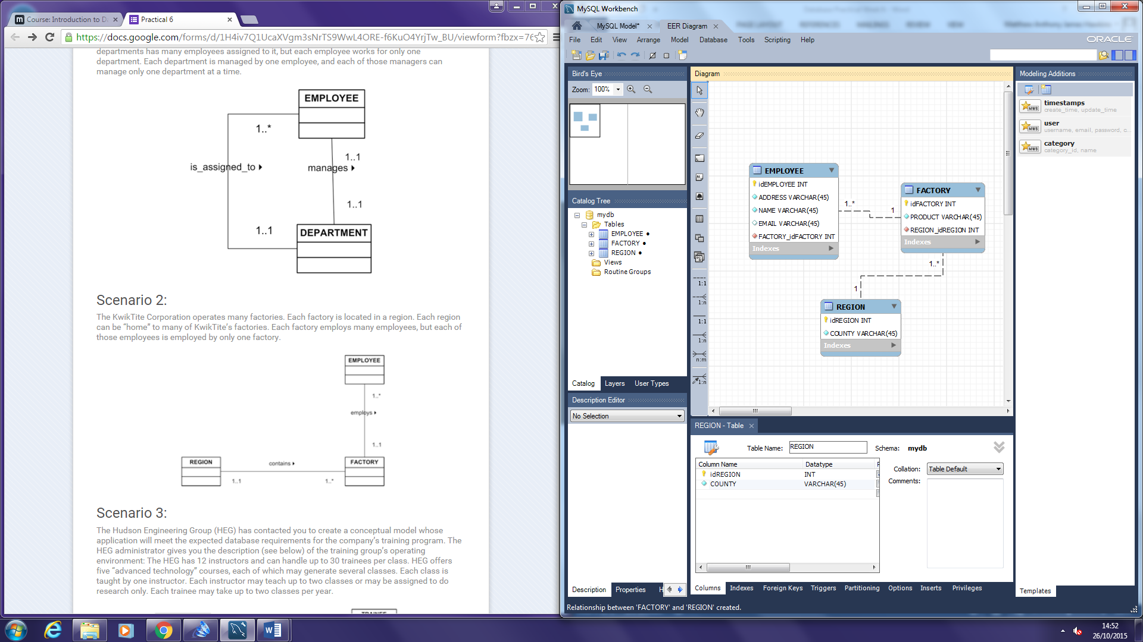

Scenario 3:

The Hudson Engineering Group (HEG) has contacted you to create a conceptual model whose application will meet the expected database requirements for the company’s training program. The HEG administrator gives you the description (see below) of the training group’s operating environment: The HEG has 12 instructors and can handle up to 30 trainees per class. HEG offers five “advanced technology” courses, each of which may generate several classes. Each class is taught by one instructor. Each instructor may teach up to two classes or may be assigned to do research only. Each trainee may take up to two classes per year.

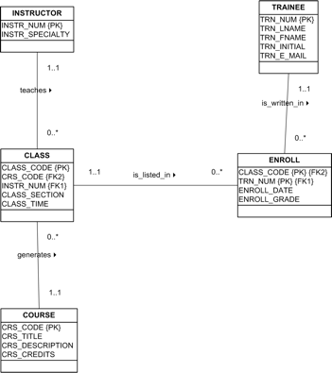

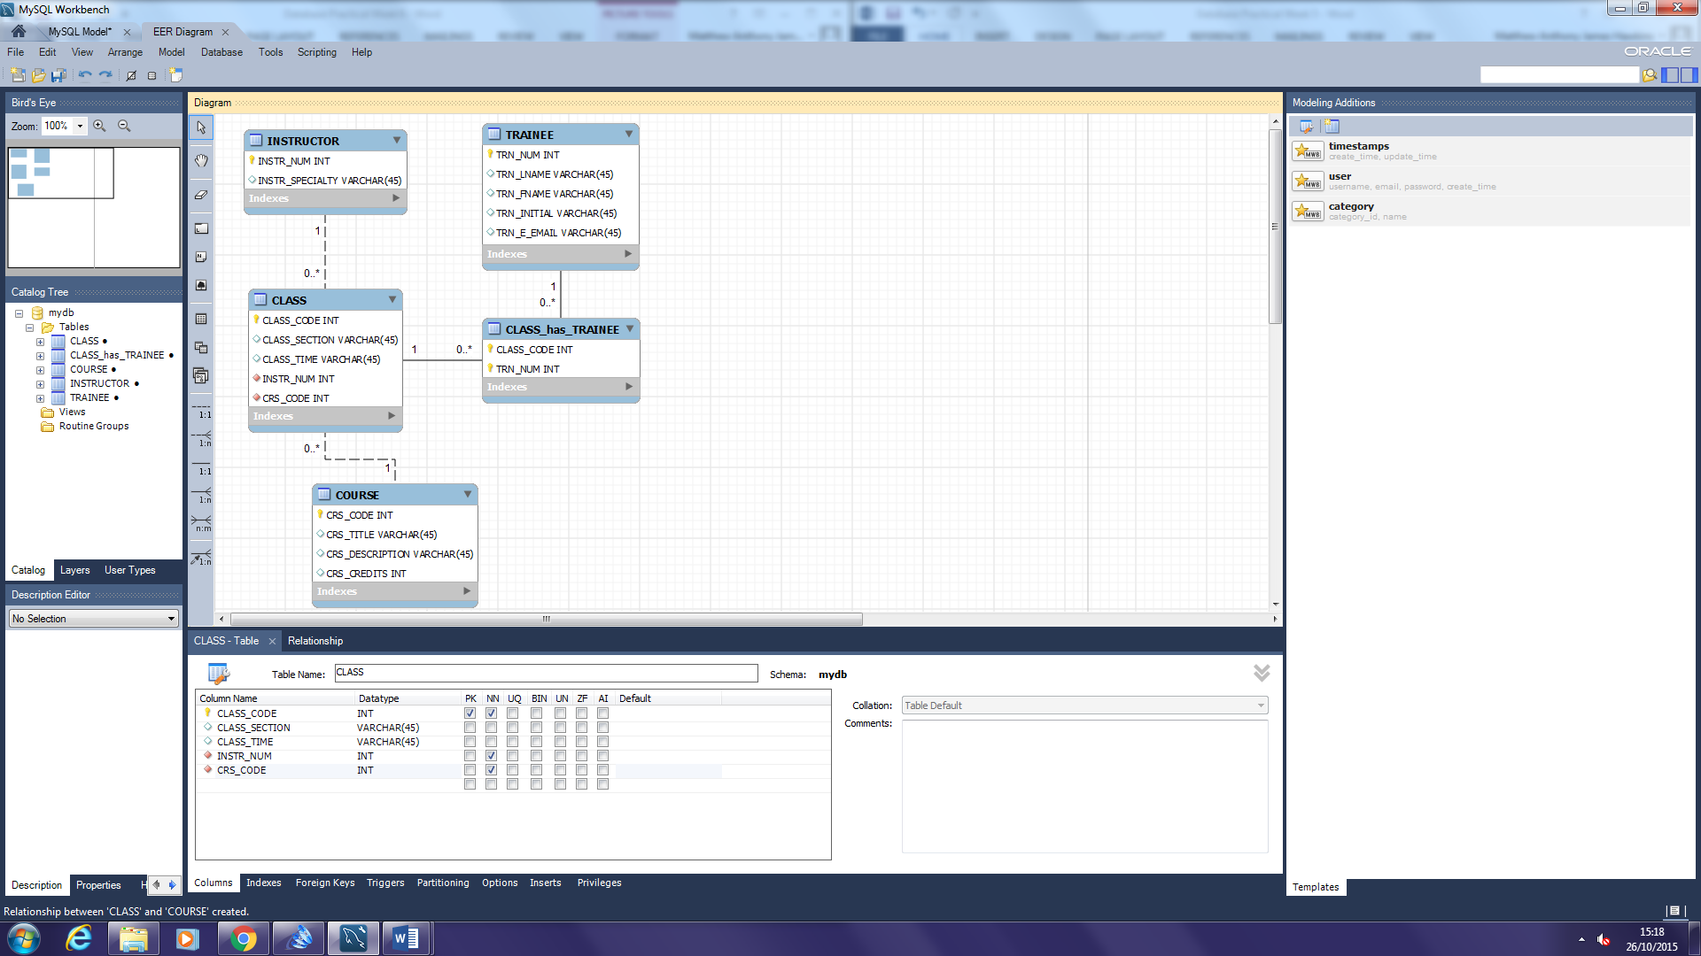

Extra - Scenario 5:

Draw this ERD in your own time after the practical session. a. A football team has at least 11 players and may have up to 40 players. b. Each player may or may not play one or more games. c. A minimum of 11 players and a maximum of 14 players may participate in one game. d. A player may or may not score one or more goals. e. Each game may have zero or more goals.

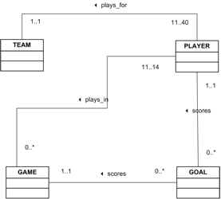

Extra - Scenario 6:

Draw this ERD in your own time after the practical session. a. A musician makes at least one recording, but may over a period of time make many recordings. b. One recording consists if at least 3 or more tracks. c. A track can appear on more than one recording.

